Mortgages

**Key Components of Mortgages**

1. **Principal**: The amount of money borrowed to buy the home.
2. **Interest**: The cost of borrowing the principal, expressed as a percentage rate.
3. **Term**: The length of time over which the loan must be repaid, typically 15 or 30 years.
4. **Down Payment**: The initial upfront portion of the total home price paid by the borrower.
5. **Amortization**: The process of paying off the loan in regular installments over time.
6. **Fixed-Rate vs. Adjustable-Rate**: Mortgages can have fixed interest rates (which remain constant over the loan term) or adjustable rates (which can change periodically based on market conditions).

**Types of Mortgages**

1. **Conventional Mortgages**: These are not insured or guaranteed by the federal government. They usually require higher credit scores and down payments.
   * **Conforming Loans**: Meet the standards set by Fannie Mae and Freddie Mac.
   * **Non-Conforming Loans (Jumbo Loans)**: Exceed the maximum loan limits set by Fannie Mae and Freddie Mac.
2. **Government-Backed Mortgages**: These are insured or guaranteed by the federal government, making them more accessible for borrowers with lower credit scores or smaller down payments.
   * **FHA Loans**: Insured by the Federal Housing Administration, these loans require lower down payments and are accessible to borrowers with lower credit scores.
   * **VA Loans**: Guaranteed by the Department of Veterans Affairs, available to veterans, service members, and certain military spouses, often requiring no down payment.
   * **USDA Loans**: Offered by the United States Department of Agriculture, designed for rural and suburban homebuyers, often with no down payment required.
3. **Fixed-Rate Mortgages**: The interest rate remains the same for the entire term of the loan, providing consistent monthly payments.
   * **30-Year Fixed-Rate**: Common due to lower monthly payments spread over a longer period.
   * **15-Year Fixed-Rate**: Higher monthly payments but lower total interest paid over the life of the loan.
4. **Adjustable-Rate Mortgages (ARMs)**: The interest rate can change periodically, usually in relation to an index, and payments may go up or down accordingly.
   * **5/1 ARM**: Fixed rate for the first 5 years, then adjusts annually.
   * **7/1 ARM**: Fixed rate for the first 7 years, then adjusts annually.
5. **Interest-Only Mortgages**: For a specified number of years, the borrower pays only the interest on the loan. After the interest-only period, the loan converts to a standard principal-and-interest mortgage, usually resulting in higher monthly payments.
6. **Balloon Mortgages**: Offer lower monthly payments initially but require a large lump-sum payment at the end of the loan term.

**Mortgage Process**

1. **Pre-Approval**: Before shopping for a home, borrowers often get pre-approved for a mortgage to understand how much they can afford.
2. **Application**: The borrower submits a mortgage application along with necessary documentation (income verification, credit report, etc.).
3. **Underwriting**: The lender assesses the borrower’s ability to repay the loan, examining credit history, income, assets, and debt.
4. **Approval**: If the borrower meets the lender’s criteria, the mortgage is approved.
5. **Closing**: The final step where the borrower signs the mortgage documents, and the funds are disbursed to the seller. The borrower then takes possession of the property.

**Mortgage Payments**

Mortgage payments typically include:

* **Principal and Interest**: The repayment of the loan amount and the interest on it.
* **Taxes and Insurance**: Property taxes and homeowner's insurance premiums, often collected by the lender and held in an escrow account.

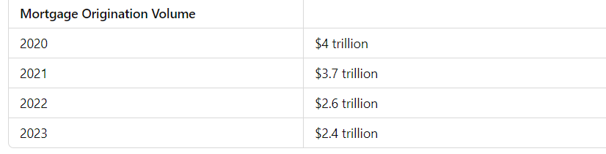

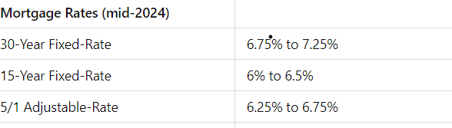

Auto loans

**Key Components of Auto Loans**

1. **Principal**: The amount of money borrowed to purchase the vehicle.
2. **Interest Rate**: The cost of borrowing the principal, expressed as a percentage rate.
3. **Term**: The length of time over which the loan must be repaid, typically ranging from 36 to 72 months.
4. **Down Payment**: The initial upfront portion of the vehicle’s purchase price paid by the borrower.
5. **Monthly Payments**: Regular payments made to repay the loan, which include both principal and interest.

**Types of Auto Loans**

1. **New Car Loans**: Loans specifically for purchasing new vehicles, often with lower interest rates due to the lower risk of depreciation.
2. **Used Car Loans**: Loans for purchasing used vehicles, generally at higher interest rates than new car loans due to higher risk.
3. **Lease Buyout Loans**: Loans that allow individuals to buy a vehicle at the end of its lease term.
4. **Refinance Loans**: Loans that replace an existing auto loan with a new one, typically to secure a lower interest rate or lower monthly payment.

**process of Obtaining an Auto Loan**

1. **Pre-Approval**: Before shopping for a vehicle, borrowers can get pre-approved for an auto loan to understand how much they can afford.
2. **Application**: The borrower submits an auto loan application with necessary documentation (income verification, credit report, etc.).
3. **Approval**: The lender assesses the borrower’s creditworthiness and approves the loan if criteria are met.
4. **Vehicle Purchase**: The loan amount is disbursed to the dealer, and the borrower takes possession of the vehicle.
5. **Repayment**: The borrower makes regular monthly payments until the loan is fully repaid.

